A000-Eur-Yugoslavia-Celtic-Horse-Bronze-250 CE

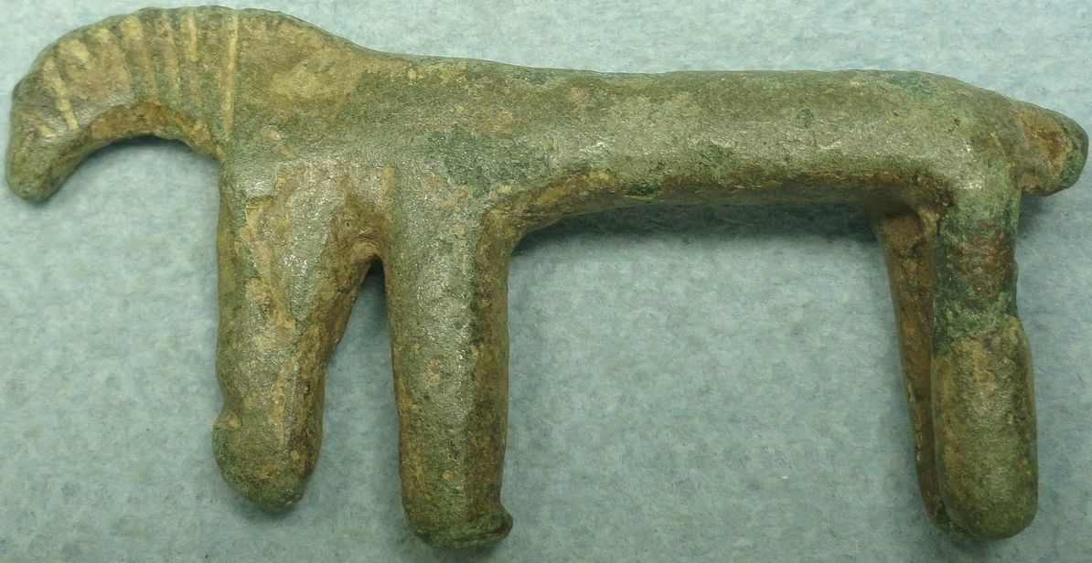

**Rider is missing. 53mm x 27mm x 10mm. Dark green patina. Found in the former Yugoslavia.**

**Case no.:**

**Accession Number:**

**Formal Label:**

**Display Description:**

**LC Classification:**

**Date or Time Horizon:**

**Geographical Area:**

**Map:**

**GPS coordinates:**

**Cultural Affiliation:**

**Media:**

**Dimensions:**

**Weight:**

**Condition:**

**Provenance:**

**Discussion:**

**References:**